**Expriment No.7**

**Code:-**

import numpy as np

import matplotlib.pyplot as plt from hmmlearn import hmm

from sklearn.preprocessing import KBinsDiscretizer, LabelEncoder from sklearn.metrics import accuracy_score

# Simulated dataset: Temperature (Celsius), Humidity (%), and Actual Weather Labels

data = np.array([

[30, 40, 'sunny'], [32, 42, 'sunny'], [35, 50, 'sunny'],

[28, 60, 'cloudy'], [26, 65, 'cloudy'], [25, 70, 'cloudy'],

[22, 80, 'rainy'], [20, 85, 'rainy'], [18, 90, 'rainy']

])

# Extract temperature, humidity, and labels temp_humidity = data[:, :2].astype(float) labels = data[:, 2]

# Encoding states weather_encoder = LabelEncoder()

states = weather_encoder.fit_transform(labels) # sunny=2, cloudy=1, rainy=0 n_states = len(set(states))

# Discrete HMM: Discretizing temperature and humidity into 3 bins discretizer = KBinsDiscretizer(n_bins=3, encode='ordinal', strategy='uniform') discrete_obs = discretizer.fit_transform(temp_humidity).astype(int)

# Train Discrete HMM

discrete_hmm = hmm.MultinomialHMM(n_components=n_states, n_iter=100) discrete_hmm.fit(discrete_obs)

predicted_states_discrete = discrete_hmm.predict(discrete_obs) accuracy_discrete = accuracy_score(states, predicted_states_discrete) # Continuous HMM: Train a Gaussian HMM

continuous_hmm = hmm.GaussianHMM(n_components=n_states, covariance_type='diag', n_iter=100)

continuous_hmm.fit(temp_humidity)

predicted_states_continuous = continuous_hmm.predict(temp_humidity) accuracy_continuous = accuracy_score(states, predicted_states_continuous) # Plot Accuracy Comparison

plt.bar(['Discrete HMM', 'Continuous HMM'], [accuracy_discrete, accuracy_continuous])

plt.ylabel('Accuracy')

plt.title('Comparison of Discrete and Continuous HMMs') plt.show()

# Print Results

print(f'Discrete HMM Accuracy: {accuracy_discrete:.2f}') print(f'Continuous HMM Accuracy: {accuracy_continuous:.2f}')

**Output:-**

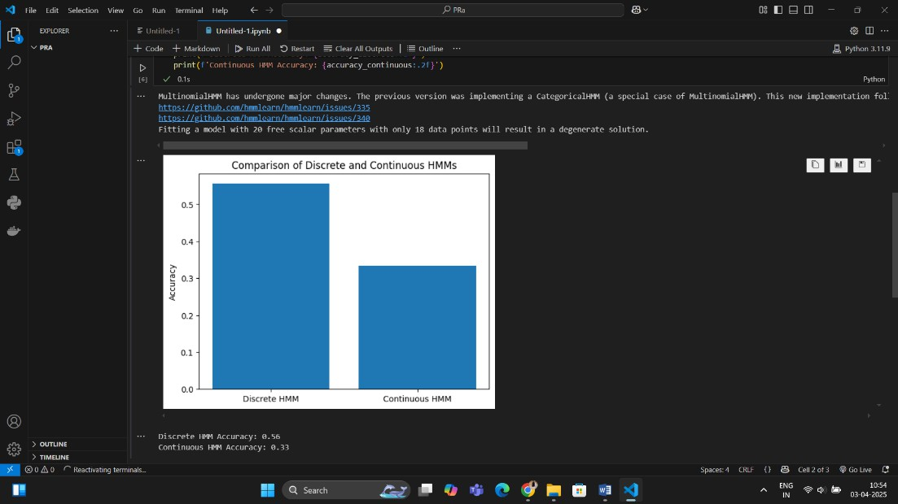

**Expriment No.8**

**Code:-**

import numpy as np

import matplotlib.pyplot as plt from hmmlearn import hmm

from sklearn.metrics import accuracy_score, classification_report, confusion_matrix

import seaborn as sns

# Define DNA sequence encoding: A=0, C=1, G=2, T=3 dna_mapping = {'A': 0, 'C': 1, 'G': 2, 'T': 3}

state_mapping = {'Exon': 0, 'Intron': 1}

reverse_state_mapping = {0: 'Exon', 1: 'Intron'}

# Sample training dataset (Observed DNA sequences and their corresponding states)

sequences = ['ATGCGT', 'CGTTAG', 'GGATCC', 'TACGTA']

states = [['Exon', 'Exon', 'Intron', 'Intron', 'Exon', 'Exon'],

['Intron', 'Intron', 'Exon', 'Exon', 'Intron', 'Exon'],

['Exon', 'Exon', 'Exon', 'Intron', 'Intron', 'Exon'],

['Intron', 'Intron', 'Exon', 'Exon', 'Exon', 'Exon']] # Convert sequences and states to numerical format

encoded_sequences = [np.array([dna_mapping[n] for n in seq]) for seq in sequences]

encoded_states = [np.array([state_mapping[s] for s in state]) for state in states]

# Flatten the sequences for training

X = np.concatenate(encoded_sequences).reshape(-1, 1) lengths = [len(seq) for seq in encoded_sequences]

y_true = np.concatenate(encoded_states) # Train Discrete HMM

model = hmm.MultinomialHMM(n_components=2, n_iter=100, tol=1e-4, random_state=42)

model.fit(X, lengths)

# Predict hidden states using Viterbi Algorithm

logprob, y_pred = model.decode(X, algorithm="viterbi") # Evaluate model accuracy

accuracy = accuracy_score(y_true, y_pred) print(f"Model Accuracy: {accuracy:.2%}")

print("Classification Report:\n", classification_report(y_true, y_pred, target_names=['Exon', 'Intron']))

# Confusion Matrix

cm = confusion_matrix(y_true, y_pred)

sns.heatmap(cm, annot=True, fmt='d', cmap='Blues', xticklabels=['Exon', 'Intron'], yticklabels=['Exon', 'Intron'])

plt.xlabel('Predicted') plt.ylabel('Actual') plt.title('Confusion Matrix') plt.show()

# Visualization of predicted gene regions plt.figure(figsize=(10, 2))

plt.plot(y_pred, label='Predicted States', marker='o', linestyle='-', color='b') plt.plot(y_true, label='True States', marker='x', linestyle='--', color='r') plt.xlabel('Position in Sequence')

plt.ylabel('State (Exon=0, Intron=1)') plt.legend()

plt.title('Gene Region Prediction')

plt.show()

**Output:-**

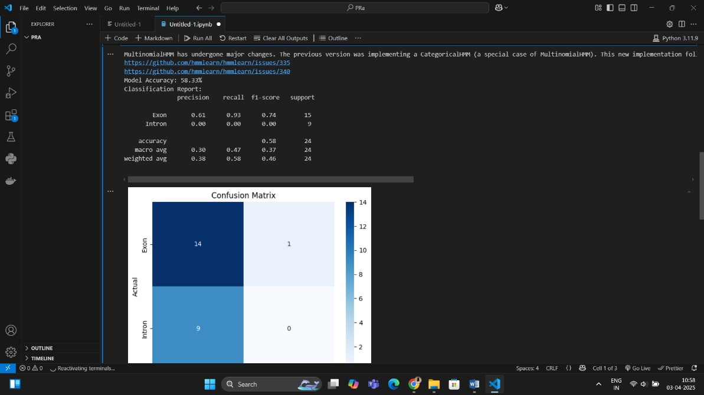

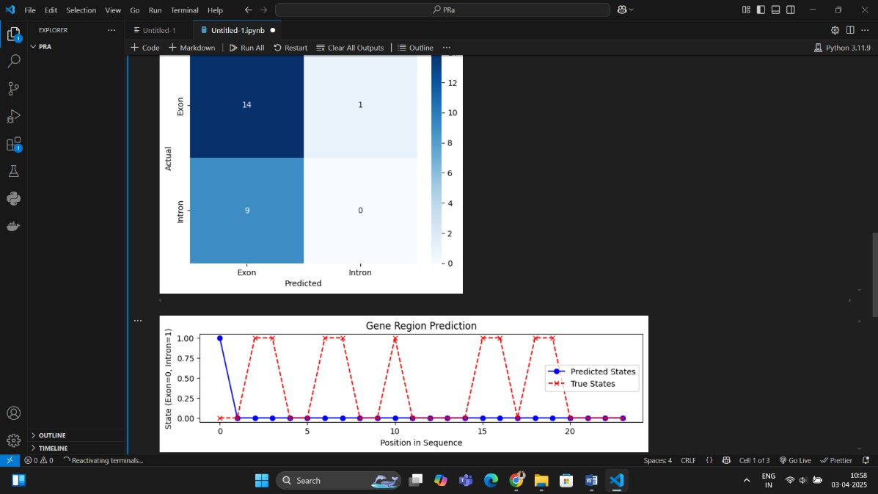

**Expriment No.10**

**Code:-**

import numpy as np

import matplotlib.pyplot as plt

from sklearn.mixture import GaussianMixture from sklearn.decomposition import PCA

from sklearn.metrics import adjusted_rand_score from sklearn.preprocessing import StandardScaler from tensorflow.keras.datasets import mnist

# Load MNIST dataset

(X_train, y_train), (X_test, y_test) = mnist.load_data() # Flatten images to 784-dimensional vectors

X_train = X_train.reshape(X_train.shape[0], -1) X_test = X_test.reshape(X_test.shape[0], -1)

# Normalize the data scaler = StandardScaler()

X_train_scaled = scaler.fit_transform(X_train) X_test_scaled = scaler.transform(X_test)

# Reduce dimensionality for better clustering pca = PCA(n_components=50)

X_train_pca = pca.fit_transform(X_train_scaled) X_test_pca = pca.transform(X_test_scaled)

# Define and fit Gaussian Mixture Model (GMM) n_components = 10 # Number of clusters (digits 0-9)

gmm = GaussianMixture(n_components=n_components, covariance_type='full', random_state=42)

gmm.fit(X_train_pca) # Predict cluster labels

train_clusters = gmm.predict(X_train_pca) test_clusters = gmm.predict(X_test_pca)

# Evaluate clustering performance using Adjusted Rand Index (ARI) ari_score = adjusted_rand_score(y_train, train_clusters) print(f"Adjusted Rand Index (ARI) on training data: {ari_score:.4f}") # Visualize the clusters using PCA (first two components)

def plot_clusters(data, labels, title): plt.figure(figsize=(8, 6))

scatter = plt.scatter(data[:, 0], data[:, 1], c=labels, cmap='viridis', alpha=0.5) plt.colorbar(scatter, label='Cluster Index')

plt.title(title)

plt.xlabel('PCA Component 1')

plt.ylabel('PCA Component 2') plt.show()

plot_clusters(X_train_pca, train_clusters, 'GMM Clustering of Handwritten Digits (Training Data)')

# Visualize cluster means (reshaped to 28x28 images) def plot_gmm_means(gmm, pca):

mean_images = pca.inverse_transform(gmm.means_).reshape(n_components, 28, 28)

plt.figure(figsize=(10, 5))

for i in range(n_components):

plt.subplot(2, 5, i + 1) plt.imshow(mean_images[i], cmap='gray') plt.axis('off')

plt.suptitle('Cluster Means (Learned by GMM)') plt.show()

plot_gmm_means(gmm, pca)

**Output:-**

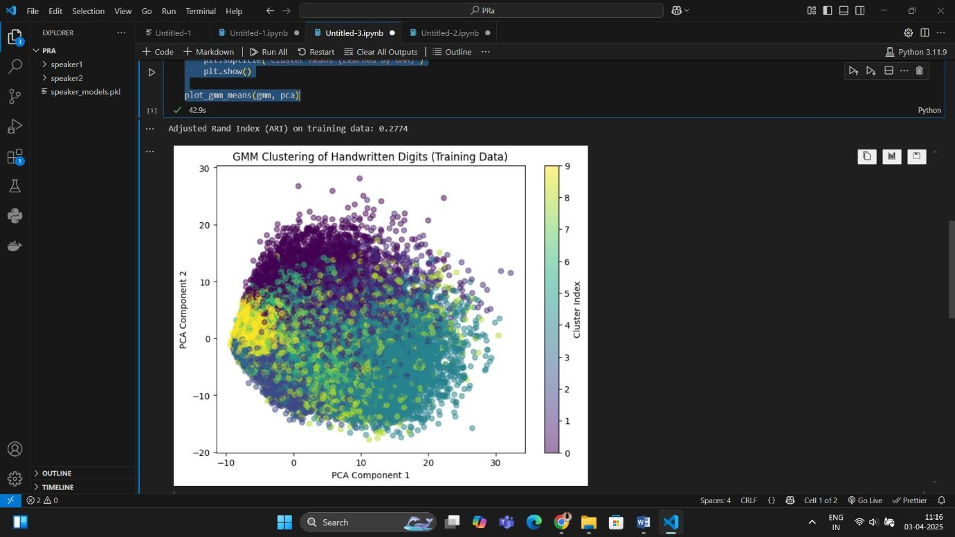

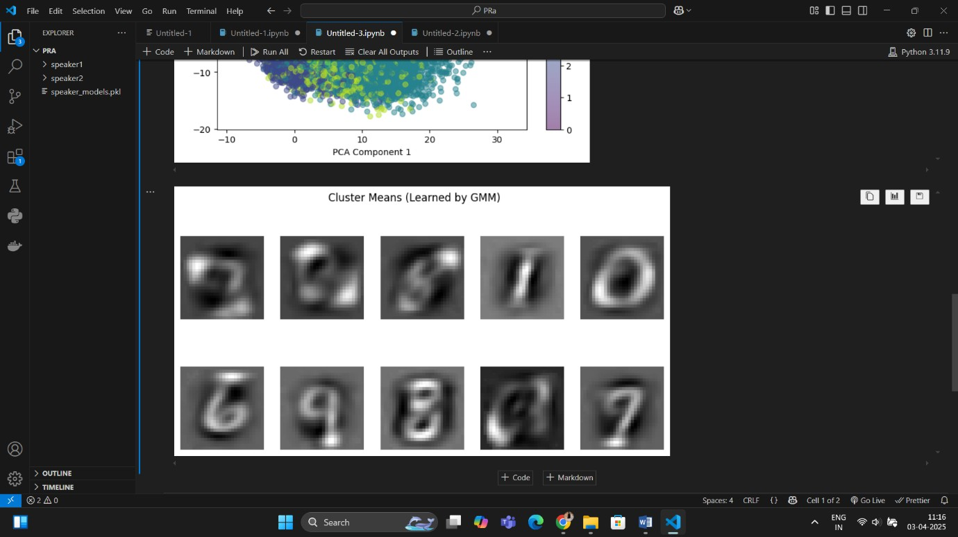

**Expriment No.11**

**Code:-**

import numpy as np import cv2

import os

# Define dataset directory dataset_path = "shapes_dataset" shapes = ["circle", "square", "triangle"]

num_images = 100 # Number of images per shape

# Ensure directories exist for shape in shapes:

os.makedirs(os.path.join(dataset_path, shape), exist_ok=True)

# Function to draw shapes

def generate_shape(shape, size=(64, 64)):

img = np.zeros(size, dtype=np.uint8) # Black background center = (size[0] // 2, size[1] // 2)

radius = 20

if shape == "circle":

cv2.circle(img, center, radius, 255, -1) elif shape == "square":

cv2.rectangle(img, (center[0] - radius, center[1] - radius), (center[0] + radius, center[1] + radius), 255, -1)

elif shape == "triangle":

pts = np.array([[center[0], center[1] - radius], [center[0] - radius, center[1] + radius],

[center[0] + radius, center[1] + radius]], np.int32) pts = pts.reshape((-1, 1, 2))

cv2.fillPoly(img, [pts], 255)

return img

# Generate and save images for shape in shapes:

for i in range(num_images): img = generate_shape(shape)

img_path = os.path.join(dataset_path, shape, f"{shape}_{i}.png") cv2.imwrite(img_path, img)

print("✅ Synthetic dataset generated successfully!") import os

import numpy as np import cv2

from sklearn.model_selection import train_test_split

from sklearn.neighbors import KernelDensity, KNeighborsClassifier from sklearn.metrics import accuracy_score, confusion_matrix import matplotlib.pyplot as plt

import seaborn as sns

# Load dataset

dataset_path = "shapes_dataset" shapes = ["circle", "square", "triangle"] img_size = (64, 64)

X = [] # Feature vectors y = [] # Labels

# Load images and extract features

for label, shape in enumerate(shapes): shape_path = os.path.join(dataset_path, shape) for img_name in os.listdir(shape_path):

img_path = os.path.join(shape_path, img_name)

img = cv2.imread(img_path, cv2.IMREAD_GRAYSCALE) # Load as grayscale img = cv2.resize(img, img_size) # Resize (optional)

X.append(img.flatten()) # Flatten image to 1D feature vector y.append(label)

# Convert to NumPy arrays X = np.array(X)

y = np.array(y)

# Split dataset (80% train, 20% test)

X_train, X_test, y_train, y_test = train_test_split(X, y, test_size=0.2, random_state=42)

# --- Parzen-Window Classifier ---

kde_models = {} # Dictionary to store KDE models per class bandwidth = 0.2 # Smoothing parameter

for label in np.unique(y_train):

kde = KernelDensity(kernel="gaussian", bandwidth=bandwidth) kde.fit(X_train[y_train == label])

kde_models[label] = kde

# Classification using Parzen-Window method y_pred_parzen = []

for x in X_test:

probs = {label: kde_models[label].score_samples([x]) for label in kde_models}

y_pred_parzen.append(max(probs, key=probs.get)) # Compute accuracy

accuracy_parzen = accuracy_score(y_test, y_pred_parzen)

print(f"🎯 Parzen-Window Classification Accuracy: {accuracy_parzen:.2f}")

# --- K-Nearest Neighbors Classifier ---

knn = KNeighborsClassifier(n_neighbors=5) knn.fit(X_train, y_train)

y_pred_knn = knn.predict(X_test) # Compute accuracy

accuracy_knn = accuracy_score(y_test, y_pred_knn) print(f"🎯 KNN Classification Accuracy: {accuracy_knn:.2f}") # --- Confusion Matrices ---

fig, axes = plt.subplots(1, 2, figsize=(12, 5)) # Parzen-Window Confusion Matrix

sns.heatmap(confusion_matrix(y_test, y_pred_parzen), annot=True, fmt="d", cmap="Blues",

xticklabels=shapes, yticklabels=shapes, ax=axes[0]) axes[0].set_title("Parzen-Window Confusion Matrix") axes[0].set_xlabel("Predicted") axes[0].set_ylabel("Actual")

# KNN Confusion Matrix

sns.heatmap(confusion_matrix(y_test, y_pred_knn), annot=True, fmt="d", cmap="Oranges",

xticklabels=shapes, yticklabels=shapes, ax=axes[1]) axes[1].set_title("KNN Confusion Matrix") axes[1].set_xlabel("Predicted") axes[1].set_ylabel("Actual")

plt.tight_layout()

plt.show()

**Output:-**

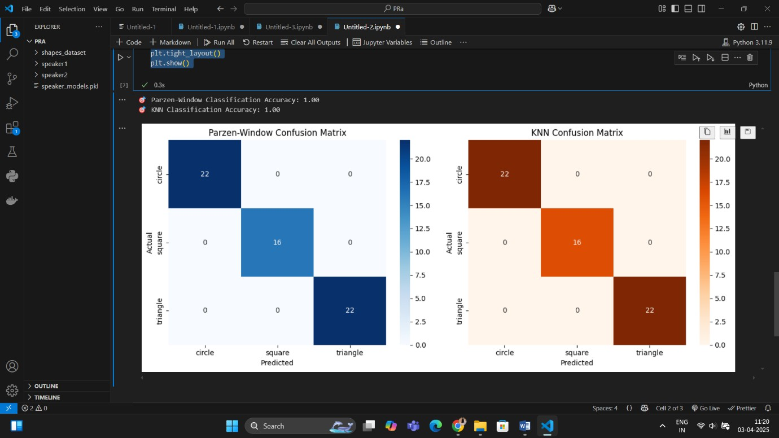

**Expriment No.12**

**Code:-**

import numpy as np import cv2

import os

import matplotlib.pyplot as plt

from sklearn.model_selection import train_test_split, GridSearchCV from sklearn.neighbors import KNeighborsClassifier

from sklearn.preprocessing import StandardScaler, LabelEncoder

from sklearn.metrics import accuracy_score, classification_report, confusion_matrix, make_scorer

import seaborn as sns

def create_shape_image(shape, size=(50, 50)): img = np.zeros(size, dtype=np.uint8)

if shape == "circle":

cv2.circle(img, (25, 25), 20, 255, -1) elif shape == "square":

cv2.rectangle(img, (10, 10), (40, 40), 255, -1) elif shape == "triangle":

points = np.array([[25, 5], [5, 45], [45, 45]], np.int32)

cv2.fillPoly(img, [points], 255) return img

def generate_dataset(samples_per_class=100): shapes = ["circle", "square", "triangle"] images, labels = [], []

for shape in shapes:

for _ in range(samples_per_class): img = create_shape_image(shape) images.append(img.flatten()) labels.append(shape)

return np.array(images, dtype=np.float32), np.array(labels) # Generate synthetic dataset

X, y = generate_dataset(samples_per_class=200) # Encode labels

label_encoder = LabelEncoder()

y = label_encoder.fit_transform(y) # Normalize features

scaler = StandardScaler() X = scaler.fit_transform(X)

# Split data into training and testing sets

X_train, X_test, y_train, y_test = train_test_split(X, y, test_size=0.2, random_state=42, stratify=y)

# Custom scoring function to handle potential errors scorer = make_scorer(accuracy_score)

# Hyperparameter tuning using GridSearchCV

param_grid = {'n_neighbors': [3, 5, 7, 9], 'metric': ['euclidean', 'manhattan', 'minkowski']}

knn = KNeighborsClassifier()

grid_search = GridSearchCV(knn, param_grid, cv=5, scoring=scorer, error_score='raise')

grid_search.fit(X_train, y_train) # Best model selection

best_knn = grid_search.best_estimator_

y_pred = best_knn.predict(X_test) # Model evaluation

accuracy = accuracy_score(y_test, y_pred) print(f'Best KNN Model: {grid_search.best_params_}') print(f'Accuracy: {accuracy:.2f}')

print('Classification Report:\n', classification_report(y_test, y_pred)) # Confusion matrix visualization

conf_matrix = confusion_matrix(y_test, y_pred)

sns.heatmap(conf_matrix, annot=True, fmt='d', cmap='Blues', xticklabels=label_encoder.classes_, yticklabels=label_encoder.classes_)

plt.xlabel('Predicted') plt.ylabel('Actual') plt.title('Confusion Matrix')

plt.show()

**Output:-**

